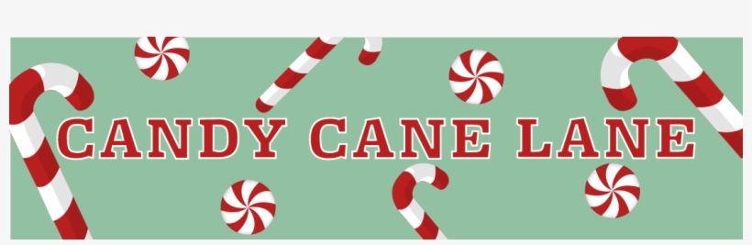
ANOTHER YEAR AT SUNY ADIRONDACK!!
THE TOWN OF QUEENSBURY PRESENTS…..
A DRIVE THRU HOLIDAY FESTIVAL
FRIDAY DECEMBER 2^{cnd} AT 6 PM.
PLEASE DRIVE THRU CANDY CANE LANE
AND MAKE STOPS AT SANTA LETTERS, QUEENSBURY FIRE COMPANIES,
TREATS BY COOL BEANS, ARTS & CRAFTS, POPCORN, CANDY JAR CONTEST,
STEWARTS ICE CREAM GIVEAWAYS,
GIFTS WITH SANTA AND SO MUCH MORE…..
PLEASE REMAIN IN YOUR CARS AT ALL TIME AND FOLLOW ALL TRAFFIC SIGNS & CONES….
Sponsored by:
